Date the following information was provided: 2022/07/27

Information Sheet
Conference title | International Conference on Slips, Trips, and Falls Sendai 2022 (STF Sendai 2022)
Conference theme | N/A
Dates | July 22-23, 2022
Hosting society | IEA Slips, Trips, and Falls Technical Committee
Participating countries | Australia, Canada, China, Germany, Indonesia, Ireland, Japan, Saudi Arabia, Switzerland, United Kingdom, United States of America
# of participants | 84 (on-site participants: 33, virtual participants: 51)
Keynote speakers | - Prof. Stephen Lord (Neuroscience Research Australia, Australia)  - Prof. Rezaul Begg (Victoria University, Australia)  - Mr. Kenichi Harano (Institute of Sport Science, ASICS Corporation, Japan)  - Prof. Yasuhisa Hirata (Tohoku University, Japan)
Other VIPs | N/A
Seminars/Workshops | Organized a Laboratory visit for 20 on-site attendees

Highlights and notable achievements:
- The 14th STF conference is held in Sendai, Japan.
- Four keynote lectures were given by specialists in neuroscience, assistive technology, sports science, and robotics. 45 oral presentations from diverse filed related to slips, trips, and falls.
- The hybrid conference (on-site and virtual) was successful. We asked all the presenters to submit pre-recorded presentation videos and use them for the presentation at the conference, which was effective for running the conference on time. The presentation videos can be viewed after the conference until August 31, 2022, which we think contributed to the increasing number of virtual participants from oversea. Both on-site participants and virtual participants enjoyed the live Q&A sessions and provided positive feedback.
- We received strong support from the School of Engineering of Tohoku University, the Japanese Human Factors and Ergonomics Society, the Japanese Society for Fall Prevention, the Japanese National Institute of Occupational Safety and Health (JNIOSH), and the Japanese Society of Biomechanism.

Overall self-evaluation: We had to hold the conference in a hybrid format due to the pandemic of COVID-19. However, I believe that the hybrid conference was successful. All keynote lectures were well received, and both on-site participants and virtual participants enjoyed the live Q&A sessions and provided positive feedback. We had nine technical sessions (five presentations in each session) related to architectural design, gait and balance control, slip resistance, aging, balance assessment, and falls in the workplace. The topic of presentations was diverse, and the quality of each presentation was high. So I believe participants enjoyed this hybrid conference. Thanks to the endorsement by IEA, it made it easier to get support from academic associations.
Future plan: Tentatively, the conference will be held in Toronto, Canada, on May 9 and 10, 2023.
Table(s) and Figures(s) (with captions):N/A
Photo picture(s) – jpeg (with captions)
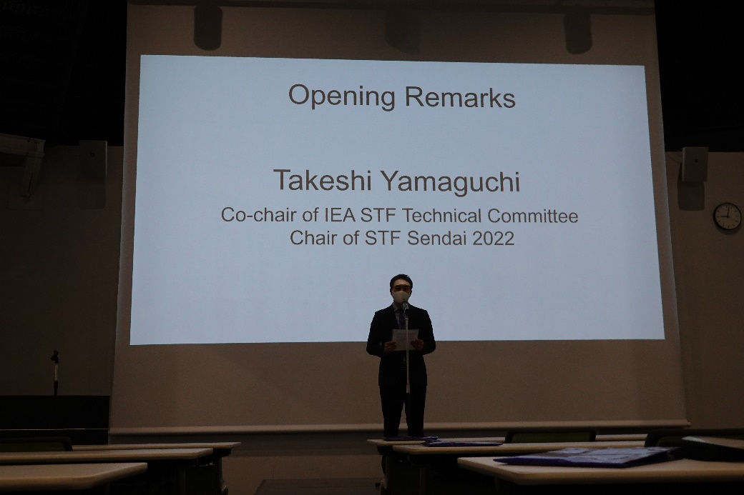
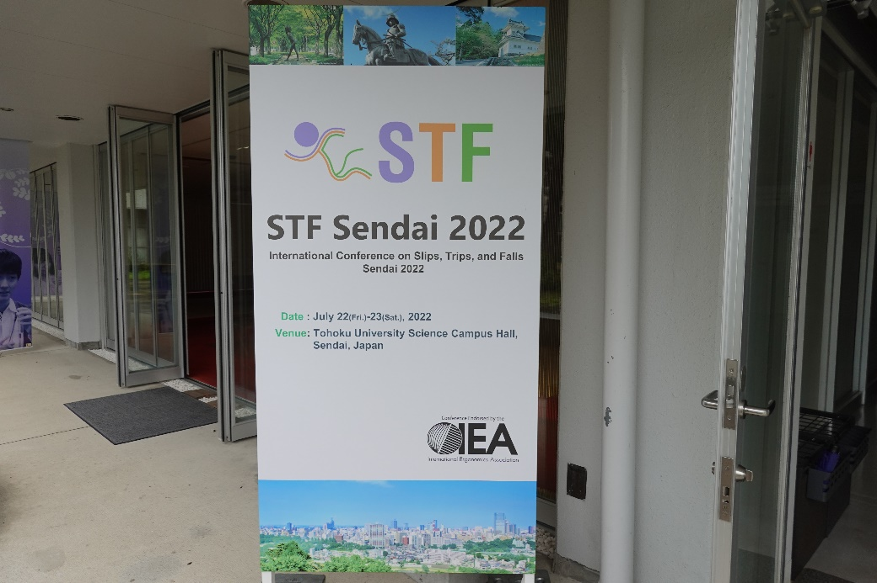

Entrance of the conference venue Opening remark
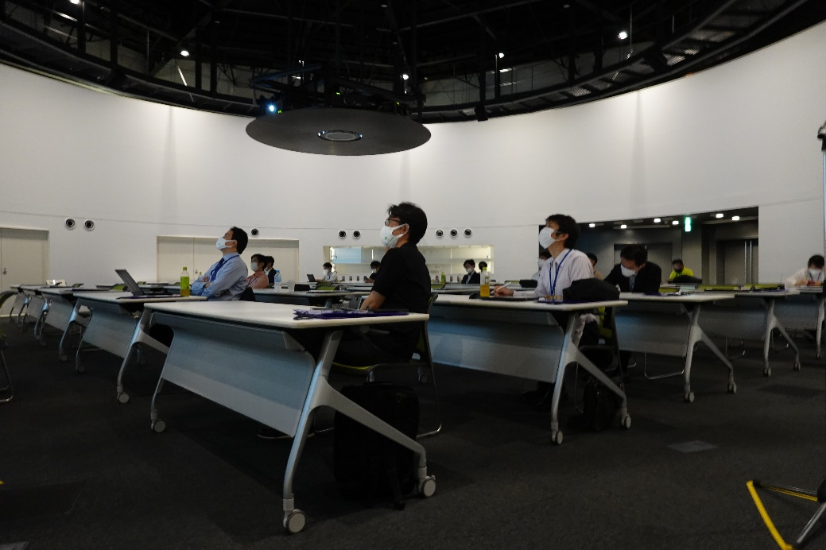
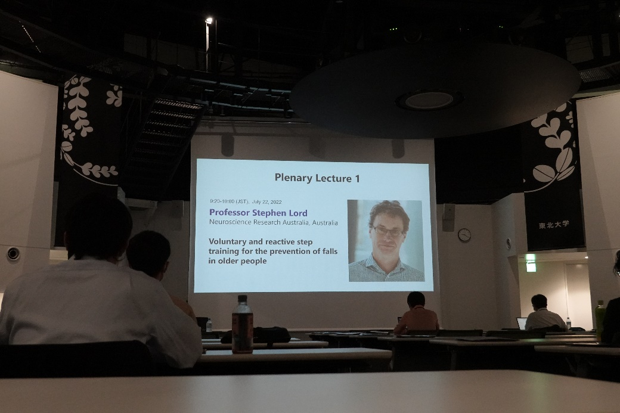

Plenary lecture Conference venue

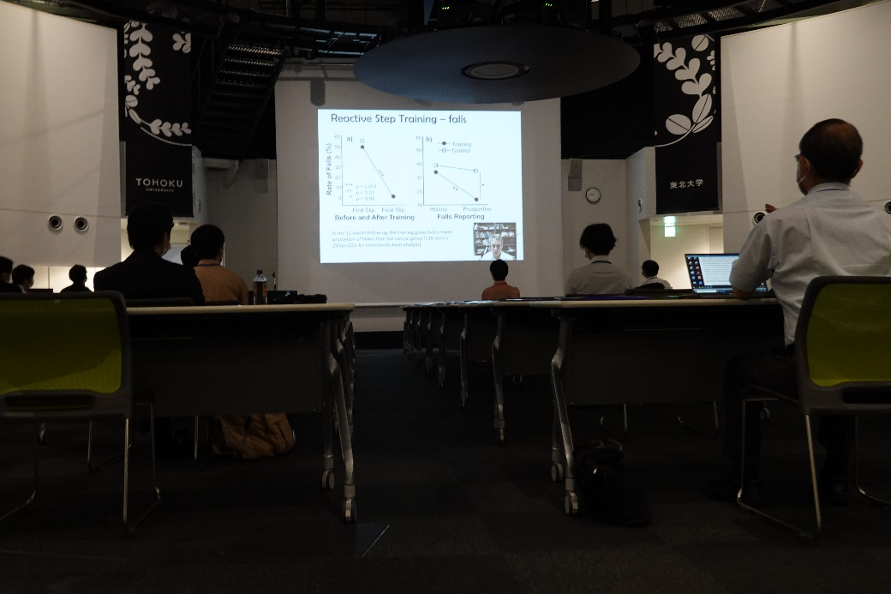
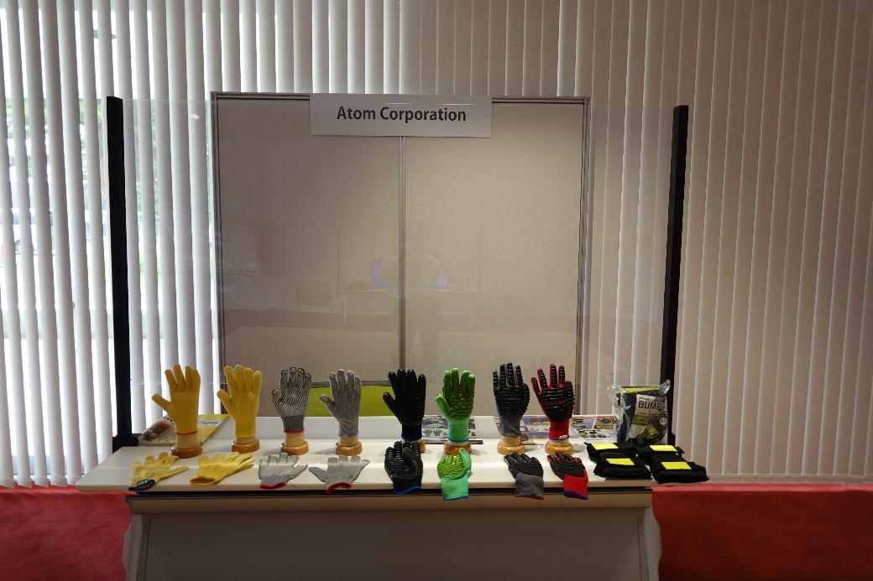

Technical session Exhibition
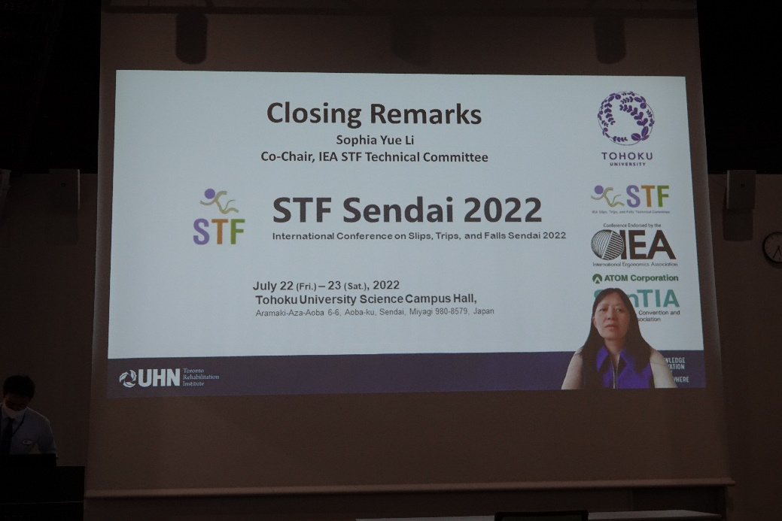
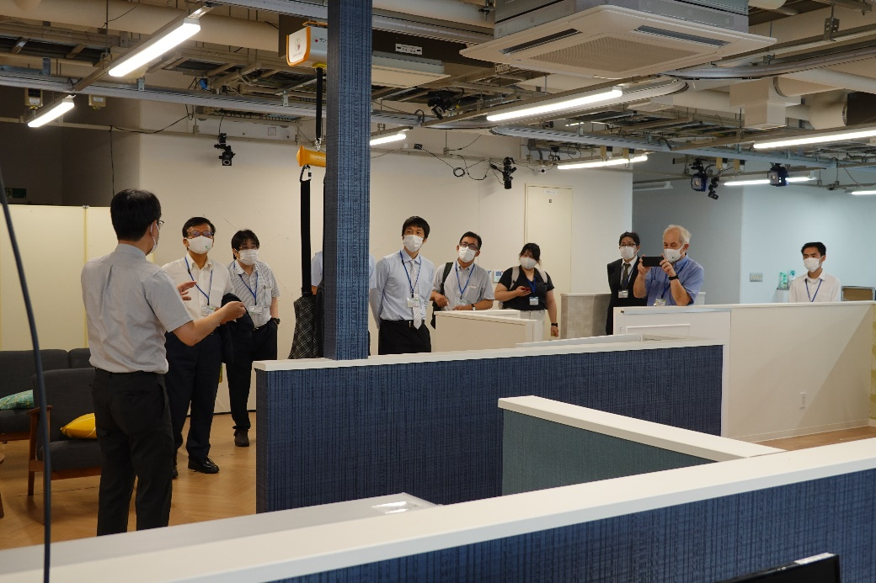

Laboratory visit Concluding remark

Name of persons who provided the above information: Takeshi Yamaguchi

End

